The presentation of Palestinians in Israeli schoolbooks of History and Geography 1994-2003
Nurit Peled-Elhanan University of Tel-Aviv and David Yellin Teachers College
All rights reserved to Nurit Peled-Elhanan

The denial of Palestinian national and territorial identity is still one of the core messages of Israeli textbooks. In a recent study of Israeli textbooks Firer (2004:75) claims that "as political correctness has reached Israel it is no longer appropriate to use blunt, discriminatory language in textbooks", and then adds that in the years 1967-1990 "the stereotypes of Arabs and Palestinians almost disappear" (ibid. p. 92). However, examining mainstream school books that were published after 1994, including the ones Firer praises most for political correctness, one cannot avoid seeing that visually and verbally, Palestinians are still represented either in a racist stereotypical way, or as absent people, namely as an 'impersonalized' or excluded element.

The Palestinian citizens of the state of Israel are always depicted dichotomously as "Israel' Arabs" vs. the Israelis, or as the "Non-Jewish population" vs. the Jewish one. For instance in SIS p. 55 there is a map titled: Rural habitation in Israel: Blue: Jewish villages, red: non-Jewish villages.(figure no. 1):

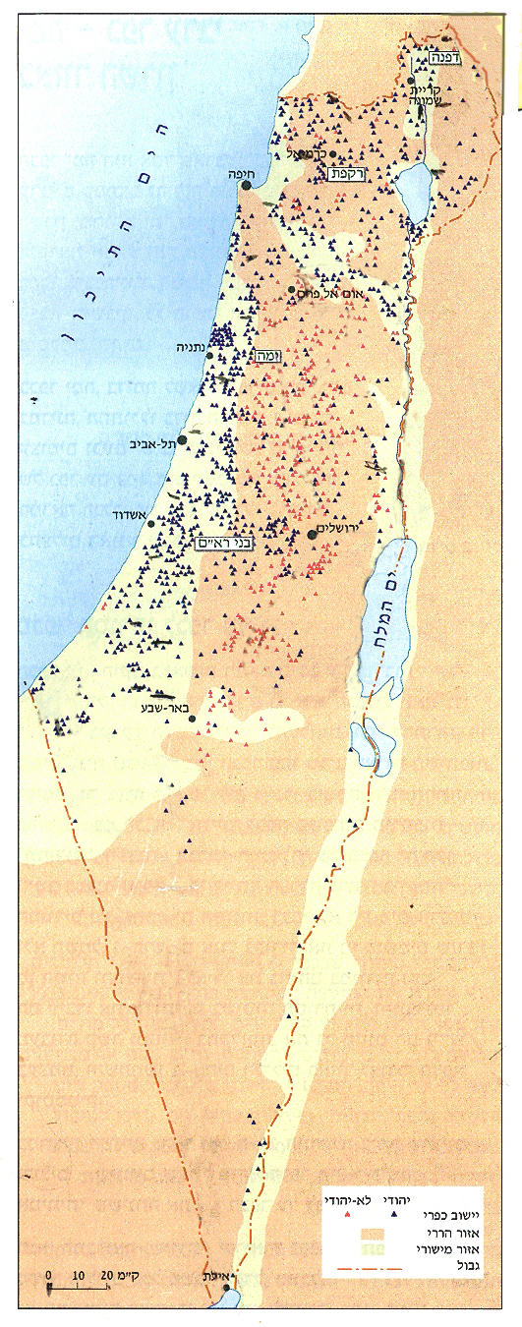

Figure no. 1: villages in Israel: blue=Jewish, red= non-Jewish.

Palestinians, both citizens and those who live under occupation, are never presented as modern, industrious individuals but always stereotypically, in racist vocabulary and racist visuals, as terrorists, as a demographic problem or as third-world 'Oxfam Images' of primitive farmers (Hicks 1980), namely as a developmental burden. Their "inferiority" is presented as a natural condition or their 'lot' and their misfortunes are either a "tragedy", an act of fate, or their own doing. Their tradition is made to signify "backwardness", and their discrimination is represented as a national necessity.
The Palestinian occupied territories are depicted on all maps as part of the state of Israel but their Palestinian inhabitants are missing from maps, photographs and graphs (figure no.2). Israeli school books present the ideal of an Arab-free land as a gurantee for the existence of the Jewish state.
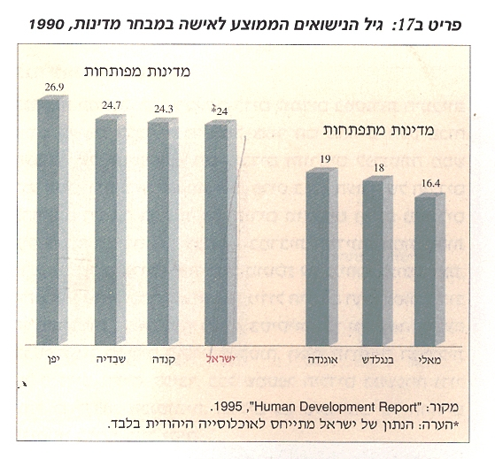
Figure no. 2: Developed countries (left) vs. undeveloped countries (right): 'Average marital age 1990. *note: Israeli data refer only to the Jewish population.' (People In Space, p. 76)

In this graph Israel manages to be the last one of the list of developed country apparently because the graph does not include the Non-Jewish population. Defining the Palestinian citizens as "non-Jews" namely as non-entity is an example of what Van Leeuwen (1996:46) terms: genericisation – one of the characteristics of racist discourse which is usually realized by "a generic name in the plural without the article". It is a perfect way to impersonalize them and as Van Dijk puts it:
"Dominance, differentiation, diffusion, diversion, impersonalisation , destruction, and daily discrimination […] serve in various ways to legitimate and enact the distinction of the "other" […] by dominating the minority groups, by excluding them from social activities and even by destroying and murdering them"(Quoted in: RW 2001: 21).

The non-Jews, regardless of their origin and faith, are sometimes called by the generic hyperonym: Arabs. For instance:

Israel the Mam and the Space, p. 12- "The Arab Population: Within this group there are several religious groups and several ethnic groups: Muslims, Christians, Druze, Bedouins and Cirkassians. But since most of them are Arab they shall be referred to henceforth as Arabs."

These 'Arabs' are presented as 'the enemy from within' and therefore, as one Geography book explains, they must be kept from 'invading state lands', for they threaten to 'create a non-Jewish sequence which would separate these areas from the state of Israel' (Geography of the Land of Israel, p. 240).

The Palestinian Problem
One of the features of racist discourse is the reference to humans by an abstract noun that does not include the semantic feature + human, and represents "social actors by means of a quality assigned to them" for instance the quality of being "a problem". (Van-Leeuwen 1996:60) . The only information the reader receives about this "problem" is that of a sad "lot" and of unfavourable circumstances that are presented as natural processes by means of abstract material processes or as self-directed phenomena that act independently of human social actors:
"Although Israel came victorious out of the survival-war that was forced upon her, the Palestinian problem would poison for more than a generation the relationships of Israel with the Arab world and with the international community." (Modern Times II:239).

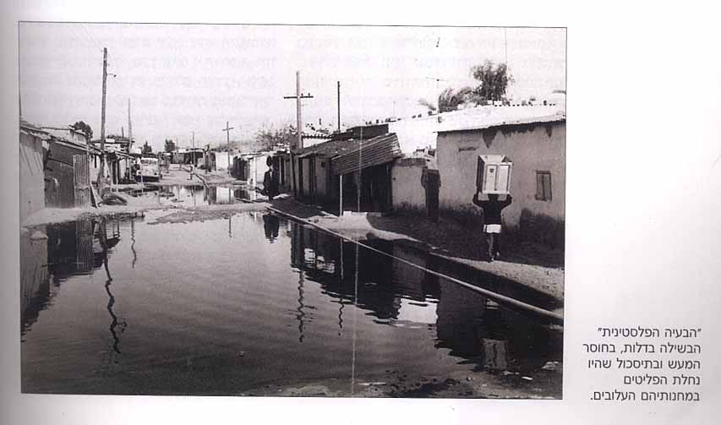
Figure no.3: "The Palestinian problem matured and festered in the poverty, the inaction and the frustration that were the refugees' lot in their pitiful camps."
(The 20th Century, p. 195)

Visually, the Palestinian problem is always presented as an environmental problem for the Israelis, such as a plague, never as the problem of the Palestinian people. In the verbal texts this is strongly emphasized:

"This chapter will explore the Palestinian problem, which stands since the beginning of the Zionist enterprise in the heart of the Middle Eastern conflict, and the attitudes within the Israeli public regarding the problem and the character of its solution".(The 20th Century p. 195.)

Though the chapter is called: The Palestinians – From refugees to a nation, One never encounters a Palestinian face throughout this chapter or any other.
Facing this title there is a photograph (figure no. 4) which has become an icon symbolizing Palestinian terror against Israeli children (the attack on a school in Maalot in 1974). For Israelis this picture is the essence of the word Palestinians, whether they are refugees or a nation. Palestinian nationality is described either as 'mock-Zionism' ("The Palestinians yearned for the land of Israel") or in negative terms, as a movement that grew out of hatred and feelings of revenge. As the book explains (p. 195): "During the years, the hate and alienation, propaganda, the hope to return and feelings of revenge turned the refugees into a nation and the refugee problem to a national problem."

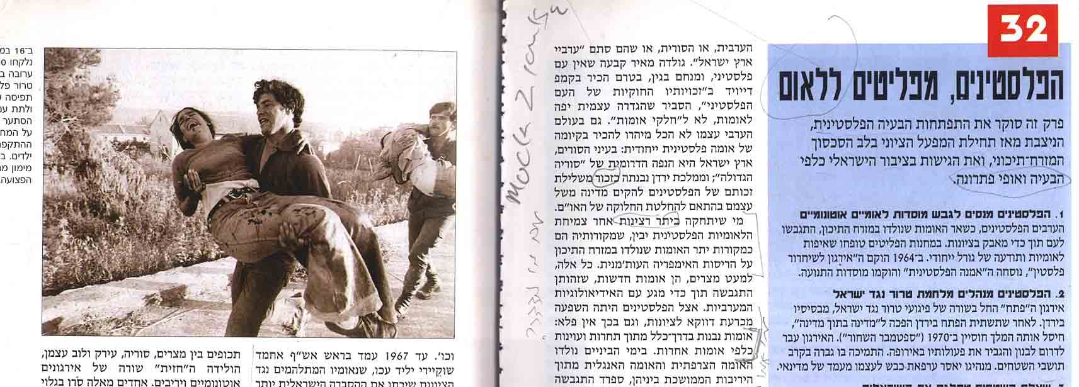
Figure no. 4: The Palestinians – From Refugees to a Nation
(with the courtesy of Israel San Agency LTD).
In the same book (p. 249) the writer, Prof. Bar-Navi, (former Israeli ambassador in France and a declared leftist), explains that annexing the west bank would turn Israel into "a bi-national state with an Arab majority and the Zionist dream into a south-African nightmare".

Just as the Palestinian problem in general is an environmental one, so is the 'refugees problem'. In People in Space - a geography book for middle school - the reader is faced with an aerial photograph of the refugee camp Jabalia. This photograph appears in a chapter called "refugees running for their lives all over the world". All other refugees, such as Rwandians, Haiitians and Jews, are depicted as human beings and their stories and routes are detailed in verbal texts and in maps. In the case of Jabalia, neither the caption nor the heading mention who lives there and why. Such an aerial view, says Van-Leeuwen (1996), is "The objective angle" which teaches students to “look high above the madding crowd" and conceals details such as people. It is the angle of the pilot who doesn’t see the people he is bombing.

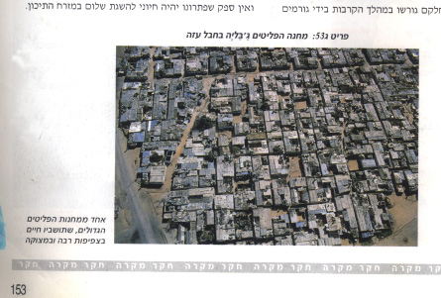
Figure no. 5: "Refugee camp Jaballia in the Gaza strip. One of the refugee camps whose overcrowded population is poor and the hygienic conditions are low."
The text under the photograph emphasizes the fact that this is an ecological problem: "The population in the refugee camps is growing fast and the conditions of life are very hard. The rate of unemployment is high, the houses are crowded and poor and the standard of health services, education and hygiene is low." (People In Space:110 figure no.5)
The Geography of exclusion
Israeli Curriculum planners have never resigned to man-made borders that seem to them an "accidental consequence of cease fire commands which paralyzed military momentum"(Bar-Gal 1993a:125), nor have they given up teaching about the Greater, "promised" Land of Israel which is "a whole Geographic entity" (ibid.). None of the schoolbooks teach about "the 'State of Israel' which has achieved international legitimation" but about "the 'Land of Israel' which has divine legitimation"(Bar-Gal 1993b:430). This is highly reinforced by frequent quotes from the Bible, that reiterate the divine promise (for instance, The Mediterranean Countries, pp.30-33).The intertextuality with the Bible gives a holy stamp to the textbook and a scientific stamp to the Bible. It also emphasises the supremacy of the divine promise over international laws and decisions.

As Bar Gal emphasizes, 'The borders of Israel as presented on the map represent the right-wing ideological perception which refuses to see the area of the West Bank and Gaza as territory under a different sovereignty.' (Bar-Gal 1993a:125)
Bar-Gal maintains that,

"The educational system […] less often emphasizes that this map is a distorted model, which sometimes can "lie," and contain items that are completely different from reality"(1996:69).
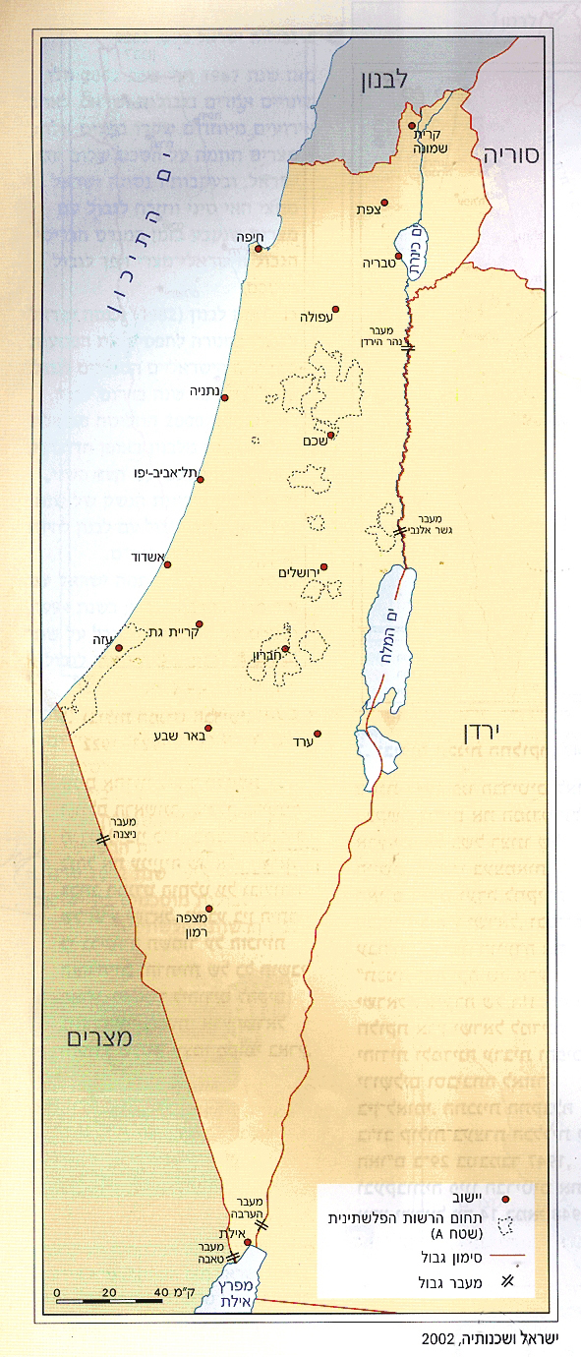

Figure no. 6: Israel-Man and Space (2003): Israel's neighbours 2002

On this map, as on all others, Arab cities within the state of Israel such as Acre or Nazareth are also omitted.
Although Palestinian territories are represented on maps as part of Israel the inhabitants of these same territories are either non-existent or depicted as "foreign" workers. However, innocent readers may not be aware of this peculiarity because the territories are not marked as Palestine:
For instance Isreal: The man and the Space p.32:

Some of the foreign workers are Palestinians…. They are employed in unprofessional jobs and their wages are lower than that of the Israeli citizens who work in the same jobs…. This is characteristic of all developed countries.

This characterization of developed countries is regarded by researchers as "The other side of western modernity: colonialism, holocaust, slavery, imperialist domination and exploitation." (Reisigle and Wodak, 2001:17).
In the same book we find maps such as 'Universities in Israel' (figure no. 7), 'The Distribution of Arab Population in Israel' (figure no. 8), and "Jerusalem as Capital' (figure no. 9), which depict the Palestinian territories as part of Israel but omit Palestinian people and institutions.
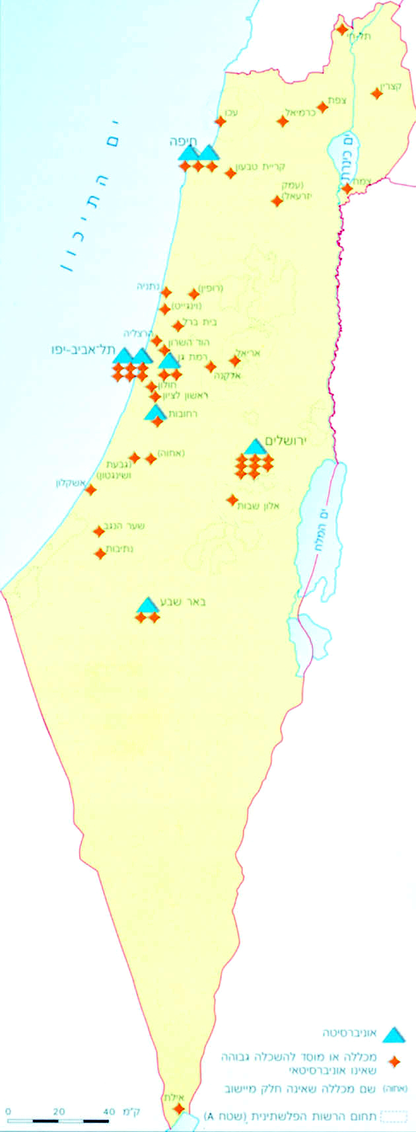

Figure no. 7: Universities in Israel. ISM p.16

Figure no. 7 shows the Jewish university extensions and small colleges in the occupied Palestinian territories but none of the Palestinian major universities or cities. Although the legend indicates the depicting of PA areas these are absent from the map itself.
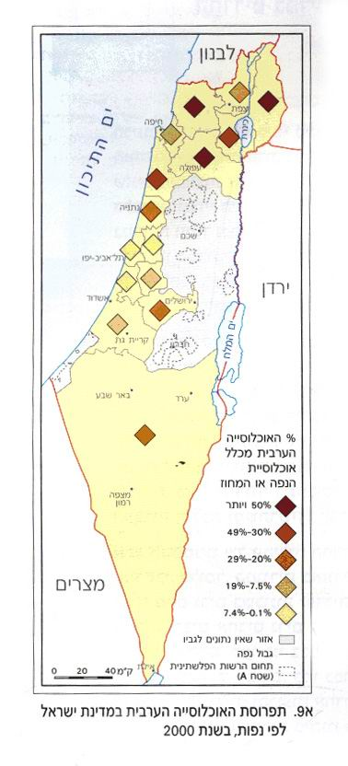
Figure no. 8: Distribution of Arab Population in Israel 2002 (white rectangle framed with a solid line: "Area without data"; White rectangle framed with a broken line: "Areas A controlled by the Palestinian Authorities").
The map representing "Arab population in Israel" leaves the Palestinian areas, which it depicts as an integral part of Israel, colorless, and the legend specifies that these areas are "areas without data" namely without registered 'Arab Population'. In view of the fact that this unknown population is the most supervised and monitored population in the world and that every soldier in every checkpoint knows about these people more that about his own, this statement is highly absurd.

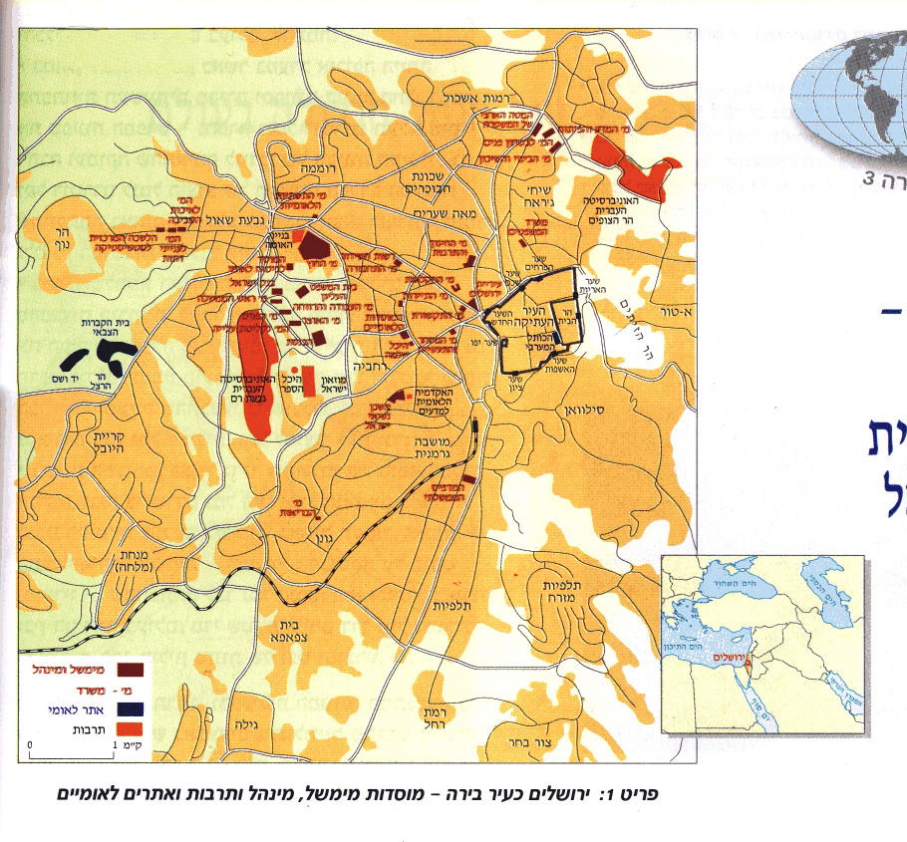
Figure no. 9: Israel-Man and Space 2003: 'Jerusalem as Capital: Government, Administration, Culture and National Sites.'

According to this map there are no Palestinian Government, administration, cultural or national site in Jerusalem at all.
These are all examples of 'Toponomic silences', which are "blank spaces, silences of uniformity, of standardization or deliberate exclusion, willful ignorance or even actual repression" (Henrikson,1994:59).

Centre and peripheralness

"One of the unfortunate consequences of colonialism and the condition it engendered, […] is a feeling that the centre is elsewhere."(Henrikson 1994:55-56)
Arabs (both Jewish and Muslim) and Arab countries are marginalized in Israeli History schoolbooks as they are marginalized in Israeli social discourse. In a History School book for grades 7-8, From Conservatism to Progress, (p.269) we learn that, "In the years 1881-1882 thousands of people arrived at Jaffa port: from Russia, from Rumania, from the Balkan and even from far-away Yemen." Needless to say, Yemen is one of the closest to Jaffa port, and the question is, why is it mentioned as the most "far away"? And how come the 4 committees that reviewed the book have never noticed the absurdity. The only answer is that the implied centre of the "mental map" of the writers is still Eastern Europe, the spiritual centre of Zionism and the origin of the dominant social group in Israel. As Henrikson explains "mental maps are a critical variable – occasionally the decisive factor – in the making of public policy" (p. 50).
Arab cities and villages within Israel are pushed to the margins of consciousness and social reality, as it is well expressed in the following statement from Geography of the Land of Israel. p.197:

Factors that inhibit the development of the Arab village

"…Arab villages [in Israel] are far from the centre, the roads to them are difficult and they have remained out of the process of change and development, they are hardly exposed to modern life and there are difficulties to connect them to the electricity and water networks."

Most of these "distant" villages are not specified on any map though they are all within the "narrow waistline of Israel" which is equal in breadth to the distance between Manhattan and JFK airport, as emphasized in Israeli maps issued by the Ministry of Foreign Affairs. However, Jewish top sites that are built on top of the hills overlooking those villages, and Jewish colonies that are beyond the official borders of Israel, are presented as examples of high standard of living and not as marginal far-away deprived settlements. But as Henrikson writes,
"The sensation of peripheralness itself cannot be altered, of course, by simply shifting or reducing the graphic frame of the map"(1994:56).

Racist cartoons
Israeli schoolbooks never show Palestinian faces, only the 'object-signs' of their stereotype (Barthes 1977:24): distant or cartoon-like figures followed by a camel, a herd of barefoot children, wearing traditional dress and kafieh. (Figure no.10).
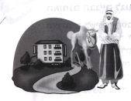
Figure no. 10: Geography of the Land of Israel: 303- "Management of land use in the Arab sector: The Arabs refuse to live in high buildings and insist on living in one-storey land-ridden houses ".

This representation is compatible with the verbal texts of the book:

The Arab society is traditional and objects to changes by its nature, reluctant to adopt novelties […] Modernization seems dangerous to them […] they are unwilling to give anything up for the general good. ( ibid)

Although Israeli researchers of textbooks such as Bar Gal (1993) who studied Geography schoolbooks, E. Podeh (2000) and R. Firer (1985, 2004) who studied History schoolbooks, insist that these books' attitude towards Palestinians is "ethnocentric" and thus differentiated from racism, researchers of racist discourse would not see the difference and for them "Ideological articulations such as racism, nationalism, sexism, ethnicism, verge on one another, are connected and overlap." (Van Dijk 1997 quoted by Reisigl and Wodak 2001:21)

Promoting the ideal of an Arab-free country: The Legitimation of massacres

Reports about massacres of Palestinians, which are told in considerable detail and may attest to a courageous educational act (Firer 2004), are never told from the victims' point of view. Rhetorically, these reports are constructed in a way that legitimates them, for they have all brought about positive changes for the Israelis. For instance, the massacre of the "friendly village" Dir Yassin in 1948 (The 20th Century p.184-195), "did not inaugurate the 'Panicked escape' of the Arabs…but accelerated it greatly". Both 'inaugurate' and 'accelerated it greatly' are positive if not festive terms. The 'panicked flight' of the Palestinians, caused by the massacres, brought about a positive change for the Jews, and as Prof. Bar-Navi emphasizes, even "moderate" Zionist leaders as the first president Haim Weizman, considered it as a "miracle", for it solved "a horrifying demographic problem", which could have been an impediment in the way of "the realization of the dream the Zionist movement fought to realize for more than half a century: the declaration of the state of the Jews" (The 20th Century p. 195).
The report about the massacre of Kibieh in 1953, headed by Ariel Sharon, who entered with his 'special unit' - the 101 - into the village and murdered 69 men, women and children, as a reprisal for the villagers' trials to cross the border and reach their original villages for their crops, is often termed "punishment" and is always accompanied by heroic photographs of the killers, many of whom are today's venerated leaders. The photograph below has become an icon in the Israeli iconography of heroism (figure no. 11). The poster above the picture says: "Growth against Siege" and the image of the lurking Arab is the justification and the legitimation of the massacre, which as most of the books explain, "restored the confidence to the Jewish population of Israel".

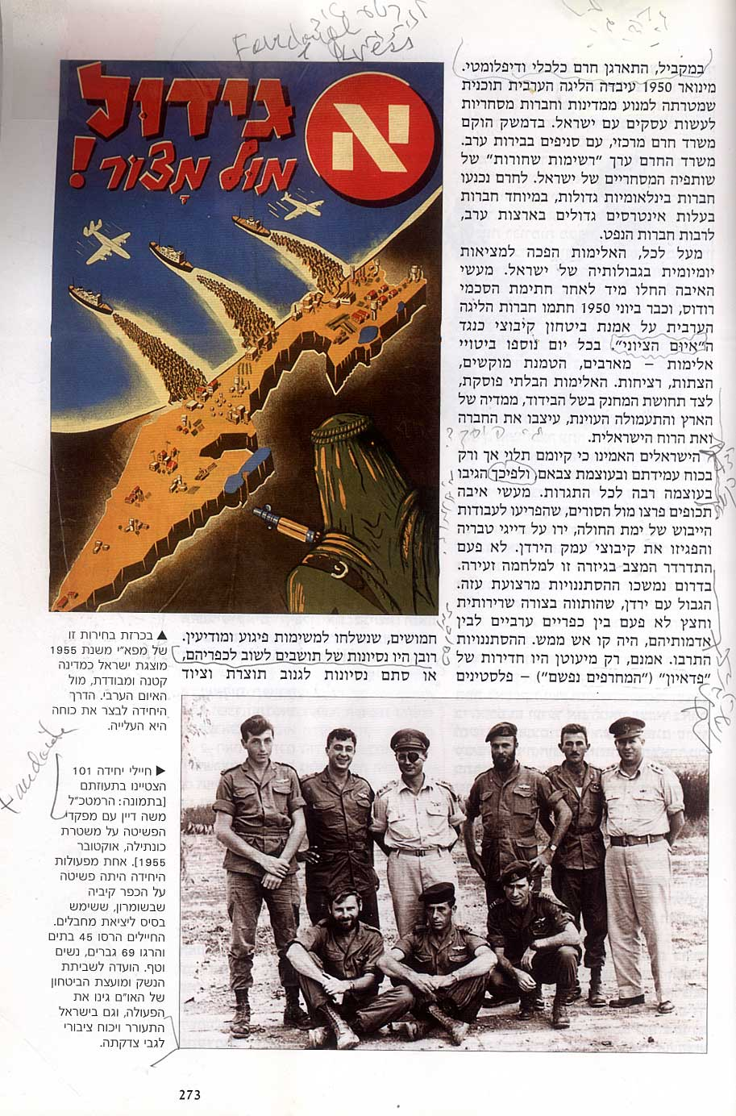

- Figure no. 11: "The soldiers of Unit 101 excelled in their daring […] One of their actions was the invasion of the village Kibieh in the Samaria region […]. The soldiers destroyed 45 houses and killed 69 men, women and children."

The massacre of 49 men, women and children in Kafar Kassem (on the first day of the 1956 war) is presented as a 'tragedy' that had positive results because it made the Israeli court rule against obedience to 'manifestly unlawful orders.' (The Age of Horror and Hope2001). Other books go as far as persuading us that it was even good for the Palestinians citizens themselves:
'The 1956 war was a good turning point for Israel's Arabs although it began with the tragedy of Kafar Kassem." That is because "in the long run, the smashing victory, the relative peace on the borders and the self confidence of the Jewish population turned the military government into an unbearable moral and political burden and ten years later it was abolished altogether." (The 20th Century (p. 211).
Students learn from this statement that immoral deeds are not rectified because they are wrong but because they may be a burden to victorious, self-confident conquerors, and have political implications. They also learn that 20 long years of life under siege (the military government) do not deserve more that one line of 'paper time' (Barthes 1967), namely that time passes more quickly for Arabs.

All these reports teach how to legitimate massacres by transcending the individual incident and considering the long term consequences from a political-military point of view. They also teach to overlook moral issues unless they have political implications. This way the students, soon to be soldiers, are introduced to the language and arguments of politicians and generals.

Conclusion:
My argument is that Israeli schoolbooks are a manifestation of "elite racism": 'racism reproduced in papers, schoolbooks, academic discourse, political speeches and parliamentary debates – the racism which is then implemented and enacted in other social fields', (Reisigl and Wodak 2001:24) such as the army. The schoolbooks which were published after the Oslo peace agreement inculcate Jewish exclusive rights of the Land and encourage the oppression of Palestinian identity and culture.
Israeli students are misinformed about the geopolitical situation of their country, and are denied the information necessary in order to regard their immediate neighbours as partners for shared life and co-existence. They learn from their schoolbooks to manipulate verbal and visual disciplinary discourse the way politicians do. They learn that democracy may segregate citizens according to ethnicity and that human suffering and empathy are race or religion-dependent.

Bibliography
A. the cited schoolbooks:
1. Aharony. Y and Sagi T. (2003) The Geography of the Land of Israel - A Geography textbook for grades 11-12 (GLI). Tel-Aviv. Lilach Pub.
2. Avieli-Tabibian, K. (2001): The Age of Horror and Hope. Chapters in History for grades 10-12 (HH). Tel-Aviv. The Centre for Educational Technologies Pub.
3. Bar-Navi, E. (1998) The 20th century- A History of the people of Israel in the last generations, for grades 10-12. Tel-Aviv. Sifrei Tel Aviv Pub.
4. Bar-Navi, E. and Nave, E. (1999) Modern Times Part II – The history of the people of Israel. For grades10-12. Tel-Aviv. Sifrei Tel Aviv Pub.
5. Eldar, Tz. And Yaffe, L.(1998): From Conservatism to Progress: History for 8th grade (FCP). Ministry of Education and Maalot publishers. Jerusalem, Israel.
6. Fine, Tz., Segev, M. and Lavi, R. (2002) Israel-The Man and the Space– selected chapters in geography (IMS). Tel-Aviv. The Centre for Educational Technologies Pub.
7. Rap, E. and Fine, Tz. (1994/1998) People in space A Geography textbook for 9th grade (PIS). Tel-Aviv. The Centre for Educational Technologies Pub.

General bibliography

Bar-Gal, Y. (1993a) Homeland and Geography in a hundred years of Zionist Education. Tel-Aviv, Am Oved Publishers.
Bar-Gal Y. (1993b) 'Boundaries as a topic in geographic education
The case of Israel.' in: Political Geography, Vol. 12, No. 5, September 1993, pp. 421-435
Bar-Gal Y. (1996) 'Ideological Propaganda in Maps and Geographical Education.' In J. van der Schee & H. Trimp, Innovation in Geographical Education, Netherlands Geographical studies, IGU, Commission on Geographical Education, Hague, pp.67-79
Bar-Gal Y. (2000) 'Values and Ideologies in place descriptions.' In: Erdkunde: archive for scientific geography Bd. 54/2. Verlag.
Bar-Gal Y. (2003) 'Geographic Politics and Geographic Education'. Conference of the Geographic Society, Bar-Illan University, Tel-Aviv, Israel.
Barthes, R. (1967) 'Le Discours de l'Histoire.' In: Le Bruissement de la Langue. Paris: Editions du Seuil.
Coffin, C. (1997) 'An investigation into secondary school history.' In: F. Christie and J.R. Martin Eds. Genres and the Institutions. Open Linguistic Series. Continuum. London and New York.
Firer, Ruth, (1985) The Agents of Zionist Education. Hakibutz HaMeuhad and Sifriyat Poalim Publishers.
Firer, R. (2004): 'The presentation of the Israeli-Palestinian conflict in Israeli history and civics textbooks'. In: Firer, R. and Adwan, S.: The Israeli-Palestinian conflict in Israeli history and civics textbooks of both nations. Hannover. Georg-Eckert-Institute fur internationale Schulbuchforschung. Verlag Hahnsche Buchhandlung.
Genette, Gérard (1982) Palimpseste: La Littérature au second degré. Paris, Editions du Seuil.
A.K. Henrikson (1994) 'The power and politics of maps'. In: Reordering the World: Geopolitical perspective on the 21st century. G.J. Demko and W.B.Wood Eds. San Francisco, Westview Press pp. 50-70.
Hicks, D. (1980) 'Images of the World: An Introduction to Bias in Teaching Materials'. Accidental Paper no. 2. Centre for Multicultural Educaiton, Institute of Education. London. UK.
Kress, G. and Van-Leeuwen, Th. (2002) 'Colour as a semiotic mode: notes for the grammar of colour.' In: Visual Communication. London. Sage Publications.
Peled-Elhanan, N. (2005): 'The Legitimation of Massacres in Israeli Textbooks of History and Geography': Paper presented at the EARLI internation conference, Cyprus, Nikosia, August, 2005.
Podeh, E. (2002) The Arab Israeli Conflict in Israeli History Textbooks, 1948-2000. London, Bergin and Garvey.
Reisigle, M. and Wodak (2001): Discourse and Discrimination: Rhetorics of racism and anti-Semitism. . London and NY, Routledge Pub.
Van Leeuwen, Th. (1992) 'The schoolbook as a multimodal text'. In: International Schulbuch Forschung Vol. 14 (1), pp. 35-58. Frankfurt. Diesterweg.
Van-Leeuwen, Th. (1995) 'Representing social action'. In: Discourse in Society, Vol.6.no.1.
Van Leeuwen, Th. (1996) 'The representation of social actors'. In: C.R. Caldas-Coulthard and M. Coulthard Eds. Texts and Practices: Readings in Critical Discourse Analysis. London, Routledge.

The study, which includes 12 schoolbooks, was completed at the Institute of Education, London University, 2004, and was granted by the Leverhulme Foundation. I thank the following publishing houses for allowing me to use the visuals: Mapa publishing House for figures no. 3, 11. The Centre for Technological Education for figures no.1,2,5,6,7,8,9. Lilach Pub. For figure no. 10. And Israel San Agency LTD for figure no. 4.
For instance PIS explains that the Palestinian refugees have remained in the refugee camps because of their unwillingness to integrate in Arab countries.
VL 2001 describes a similar attitude of the Americans treating all the "others" who were dominated by them as "blacks".
http:/www.mfa.gov.il/MFA/facts about Israel/Israel in maps#threats&topography. 1.Jan, 2004.
under which Arab citizens lived since the establishment of the state

